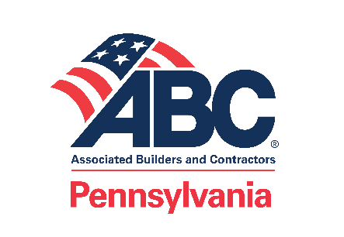
ABC Legislative Office
800 North Third Street, Suite 407
Harrisburg, PA 17102
abcpa.org

April 21, 2020
The Honorable Tom Wolf
Governor
Commonwealth of Pennsylvania
225 Main Capitol Building
Harrisburg, PA 17120
Dear Gov. Wolf:
On behalf of the Associated Builders and Contractors of Pennsylvania (ABC Pennsylvania), thank you for the opportunity to provide our input on re-opening the commercial construction industry.
We are encouraged that public and private construction will be permitted to resume on Friday, May 8. ABC Pennsylvania has been supportive of state and federal guidelines to prevent the spread of the coronavirus (COVID-19). In order to assist our members that may need resources, ABC Pennsylvania created a COVID-19 Construction Safety Task Force to provide guidance, best practices, and standards for the construction industry to incorporate into their safety plans. The task force participants included experienced safety experts across all five ABC chapters who have generously shared their collective resources aimed to protect workers and jobsites from COVID-19.
As you prepare guidance for the construction industry, we encourage you to review enclosed document entitled, Keeping Workers Safe: Recommended Guidance for the Construction Industry to Address Worker Health and Jobsite Safety in Response to COVID-19, as it provides details of industry standards.
Before commercial construction projects can restart, we fully recognize the obligation contractors and specialty contractors have in protecting their workers and the public from COVID-19. Therefore, prior to commencing work, we recommend:
- Contractors and specialty contractors create a health and safety plan that adheres to COVID-19 social distancing, mitigation, and cleaning protocols. Generally, we recommend COVID-19 mitigation plans include the following:
  - Responsibilities of employers, including manager trainings and exposure reporting.
  - Responsibilities of employees, including understanding and adhering to COVID-19 workplace health and safety protocols.
  - Utilization of personal protective equipment.
  - On-site social distancing practices.
  - Jobsite hygiene protocols.
- Contractors and specialty contractors post – at each job site – their COVID-19 control, mitigation, and safety plan.
- Commercial construction workers wear personal protective equipment (PPE) at all times.
- Develop temperature screening protocols for all employees upon discovery that the business has been exposed to a person who is a probable or confirmed case of COVID-19.
Again, thank you for the opportunity to provide our recommendations on getting construction back to work. Our goal is to ensure construction companies take the necessary precautions to protect the health and safety of their workers, and we appreciate the opportunity to present a comprehensive report.
If you have any questions, please contact ABC Pennsylvania’s Director of Government Affairs, David Greineder, at davidg@abcpa.org or (717) 951-5227.
Sincerely,
Tim Kessling
Glenn O. Hawbaker, Inc.
Board Chair, ABC Central Pennsylvania Chapter
Barbra Runyon
Brechbill & Helman Construction Company, Inc.
Board Chair, ABC Cumberland Valley Chapter
Tammi Talese
KLOVER Contracting Inc.
Board Chair, ABC Eastern Pennsylvania Chapter
Roger Brubaker
Meadow Valley Electric
Board Chair, ABC Keystone Chapter
Bob Pater
Farmers National Bank of Emlenton
Board Chair, ABC Western Pennsylvania Chapter
Enclosure: ABC Pennsylvania Construction Safety Task Force Report

Advocating for free enterprise and the merit shop philosophy throughout the Commonwealth.

